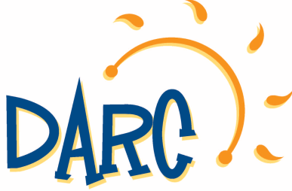
2021 Summer Camp Activity Summary
DARC Full Day Elementary Adventure Camps (for 7 to 11 year olds)
Based out of:
All Star Baseball Academy in Downingtown
&
Power Play Ice Rink in Exton

We have made many changes to our action packed Elementary Adventure Camps! Join us for a dynamic and thrilling summer!
Prices: Resident $290/wk Non-Resident $310/wk Before/After Care $50/wk
Week #1: June 21-25 Philadelphia Zoo, Turkey Hill Experience, Legoland Discovery Center, The Works, Swimming.
Week #2: June 28-July 2 Sahara Sams, Hellericks Adventure Farm, Oasis Family Fun Center, Skyzone, Swimming.
Week #3: July 5-9 Swimming, Julius Strugis Pretzel Tour, Crystal Cave, Franklin Institute, Go ‘N Bananas.
Week #4: July 12-16 Academy of Natural Sciences, Diggerland, Elite Escape, Black Rock Retreat, Swimming.
Week #5: July 19-23 Elmwood Park Zoo, Mount Gretna, National Constitution Center, Barnstormers Baseball Game, Swimming.
Week #6: July 26-30 Philadelphia Insectarium and Butterfly Pavilion, Talen Stadium Tour, Dutch Wonderland, Laserdome, Swimming.
Week #7: August 2-6 Adventure Acquarium, Longwood Gardens, American Helicopter Museum, Swimming.
Week #8: August 9-13 Arnold’s, West Chester Railroad Company, Funplex, Crayola Factory, Swimming.
Week #9: August 16-20 Milky Way Farm, Battleship New Jersey, Dutch Springs, Cherry Crest Adventure, Swimming.
Elementary Adventure Camp Trip schedule is subject to change as some locations are still working on their 2021 schedule, and may be weather dependent
Both camp locations will participate in the same activities each week this summer.

Register at: darc.info

