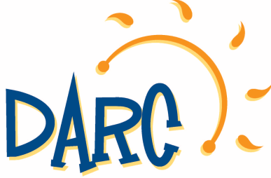
2021 Summer Camp Activity Summary
DARC Full Day Adventure Camps
Based out of:
All Star Baseball Academy in Downingtown
&
Bell Tavern Park

We have made many changes to our action packed Adventure Camps! Join us for a dynamic and thrilling summer!
Prices: Resident $290/wk Non-Resident $310/wk Before/After Care $50/wk
Week #1: June 21-25 Philadelphia Zoo, Crystal Cave, Julius Strugis Pretzel Tour, Pinball Gallery, Swimming
Week #2: June 28-July 2 Sahara Sams, Hellericks Adventure Farm, Spooky Nook, National Constitution Center, Swimming.
Week #3: July 5-9 Dutch Springs, Go ‘N Bananas, Sea Isle City, Franklin Institute, Swimming.
Week #4: July 12-16 Northbrook Canoe Company, Diggerland, Skyzone, Black Rock Retreat, Swimming.
Week #5: July 19-23 Elmwood Park Zoo, Mount Gretna, Giggleberry Fair, Barnstormers Baseball Game, Swimming.
Week #6: July 26-30 Philadelphia Insectarium and Butterfly Pavilion, Talen Stadium Tour, Dutch Wonderland, Laserdome, Swimming.
Week #7: August 2-6 Trotter Hill Alpaca Farm, Adventure Aquarium, Longwood Gardens, American Helicopter Museum, Swimming.
Week #8: August 9-13 Arnold’s, West Chester Railroad Company, Funplex, Elite Escape, Swimming.
Week #9: August 16-20 Milky Way Farm, Battleship New Jersey, Dutch Springs, Cherry Crest Adventure, Swimming.
Adventure Camp Trip schedule is subject to change as some locations are still working on their 2021 schedule, and may be weather dependent
Both camp locations will participate in the same activities each week this summer.

Register at: darc.info

